**Programming Language**

# 1-Name: - أحمد حسن محمد حسن

# 2-B.N:- 48

# 3-Topic title:- Programming Language

# 4-github links:-

# 5-github pages:-

Project Brief

This project presents some important points that affected all kinds of programming languages and that have been updated until it reached what it is today ,From these points:-

1- History of some programming languages.

2- Characters who have influenced their knowledge or material capabilities in this field.

3- Types of general frameworks for programming languages.

4- International companies that have actually developed programming languages until they reach what we are.

1. Home page ((Main Page))

On the main page, the importance of programming languages was presented in a general view; and the previous link was used to collect data.

This page contains all the links to move to the four main points that were presented in this project, through the buttons at the bottom of the page

There is also a button for some of the main program idea that has been named (The Project)

Source of Data

<https://www.linkedin.com/pulse/importance-computer-programming-azirulsyazwan-jaffar>

Page Screenshots

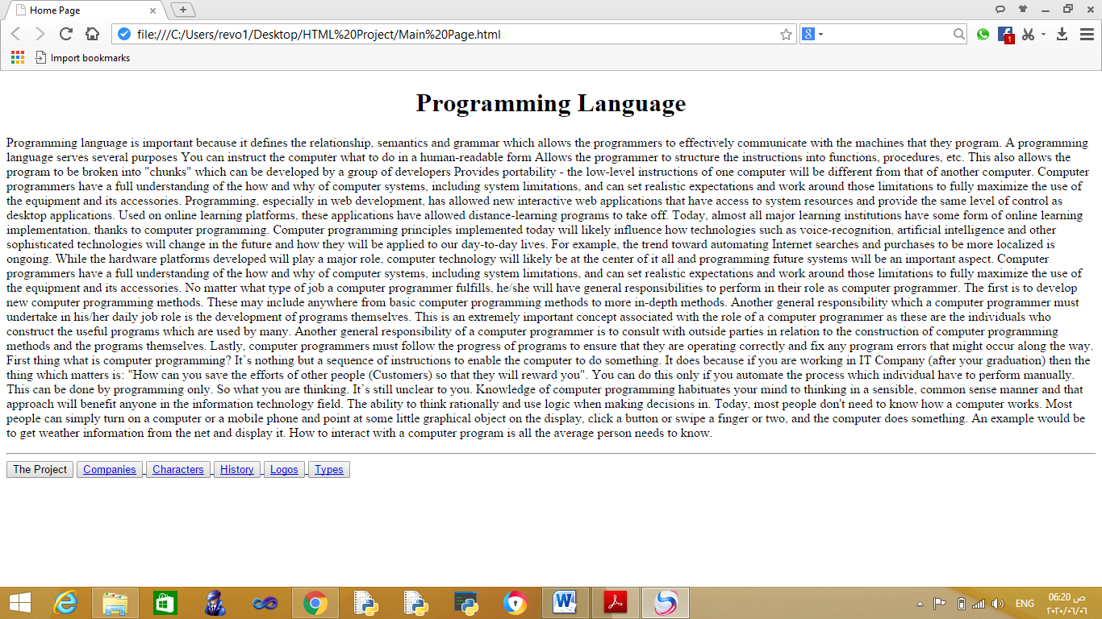

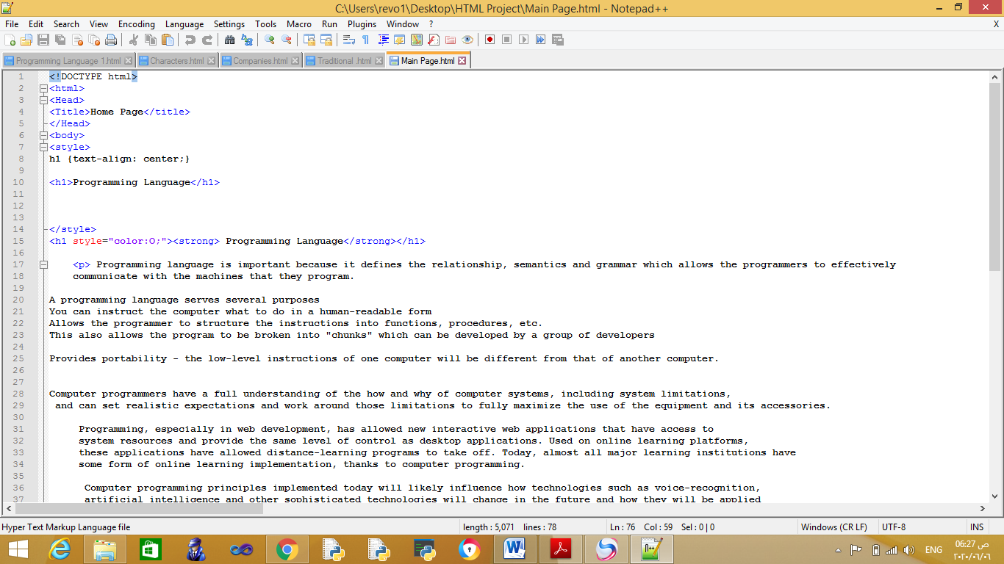

Codes Screenshots

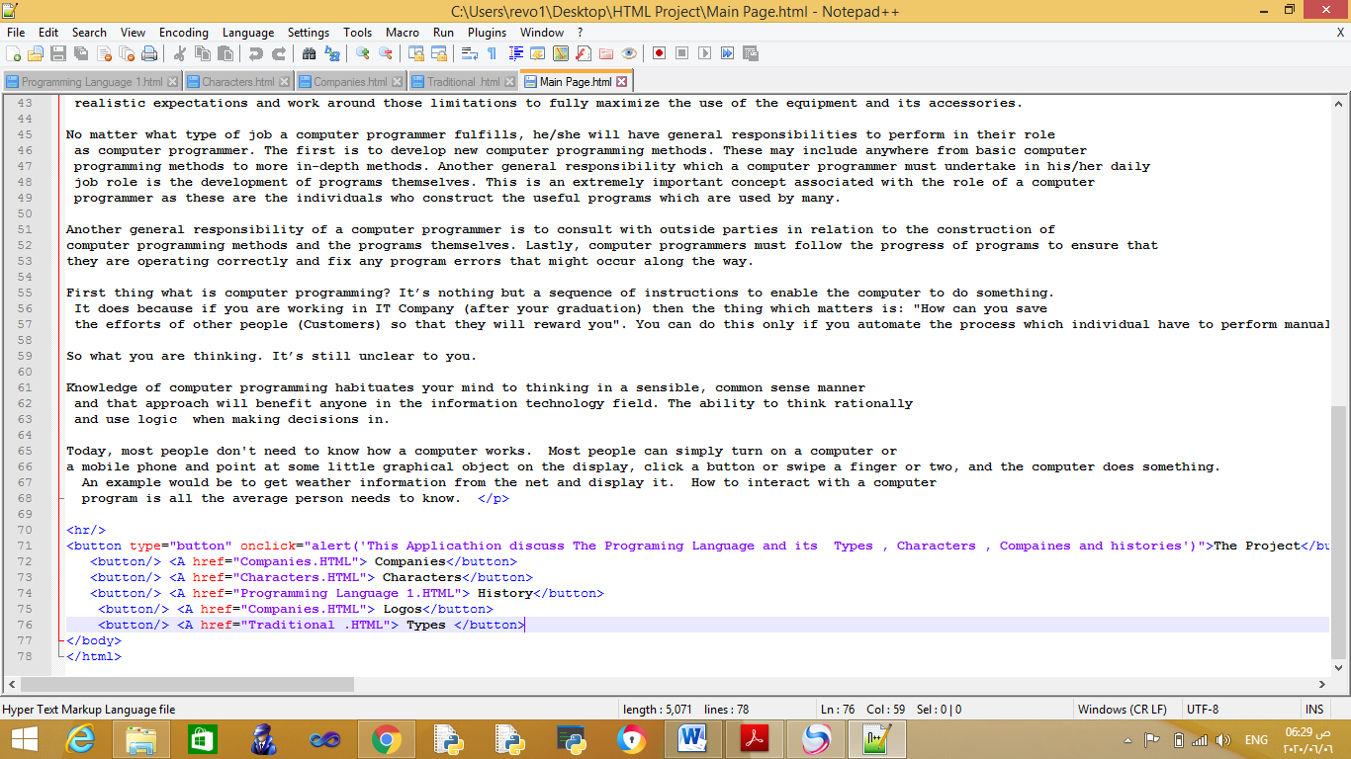

1. History of Programming Language Page

On this page, the history of programming languages was presented in a general way, by inferring 3 programming languages (Visual Basic ,Scada and P.H.P)

And some links have been set to move within the page or from this page to another; Also, some different formatting codes were used to display the page appropriately.some pictures of the offered programs were shown.

Source of Data

***History of Visual Basic***

<https://en.wikipedia.org/wiki/Visual_Basic>

***History of Scada***

<https://en.wikipedia.org/wiki/SCADA>

***History of PHP***

<http://www.nusphere.com/php/php_history>

Page Screenshots

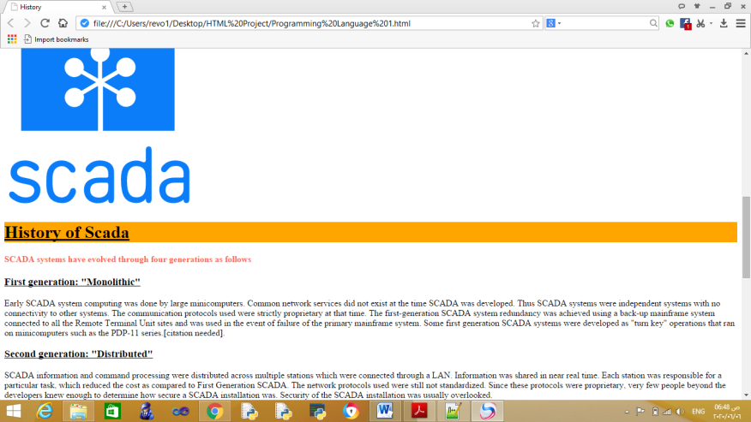

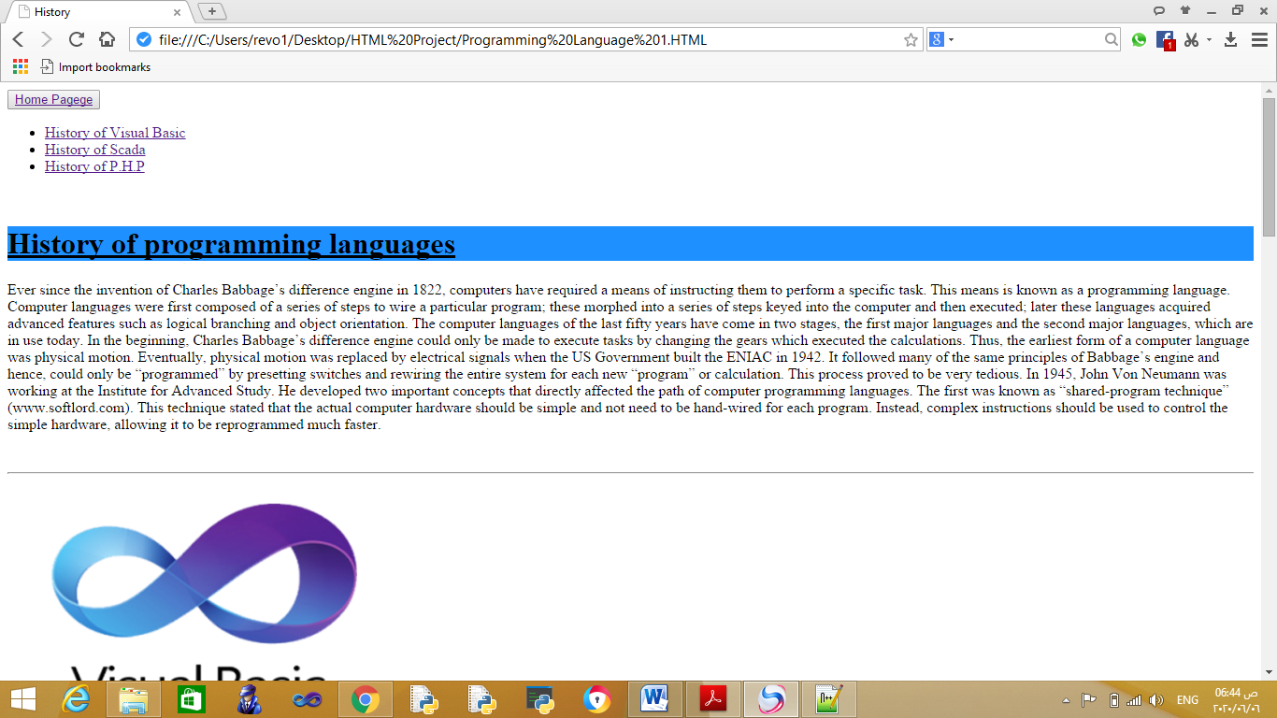

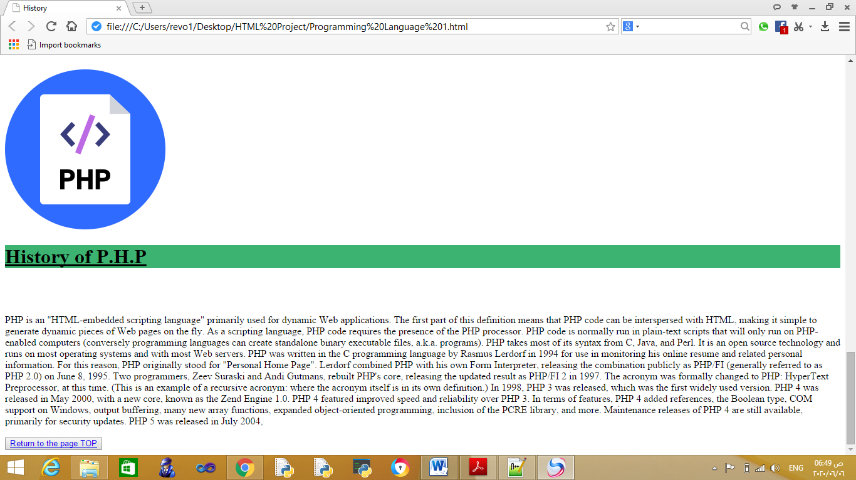

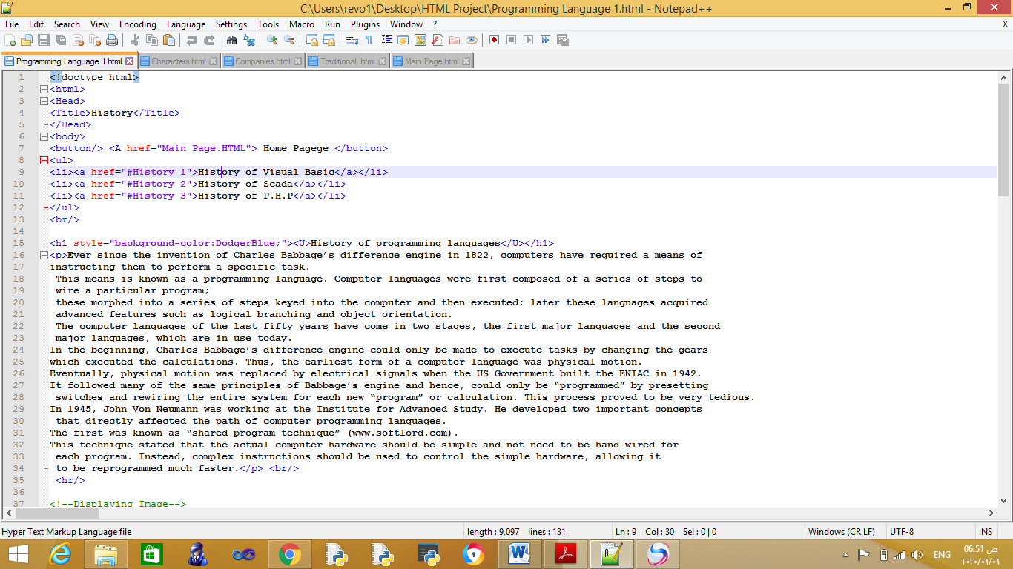Codes Screenshots

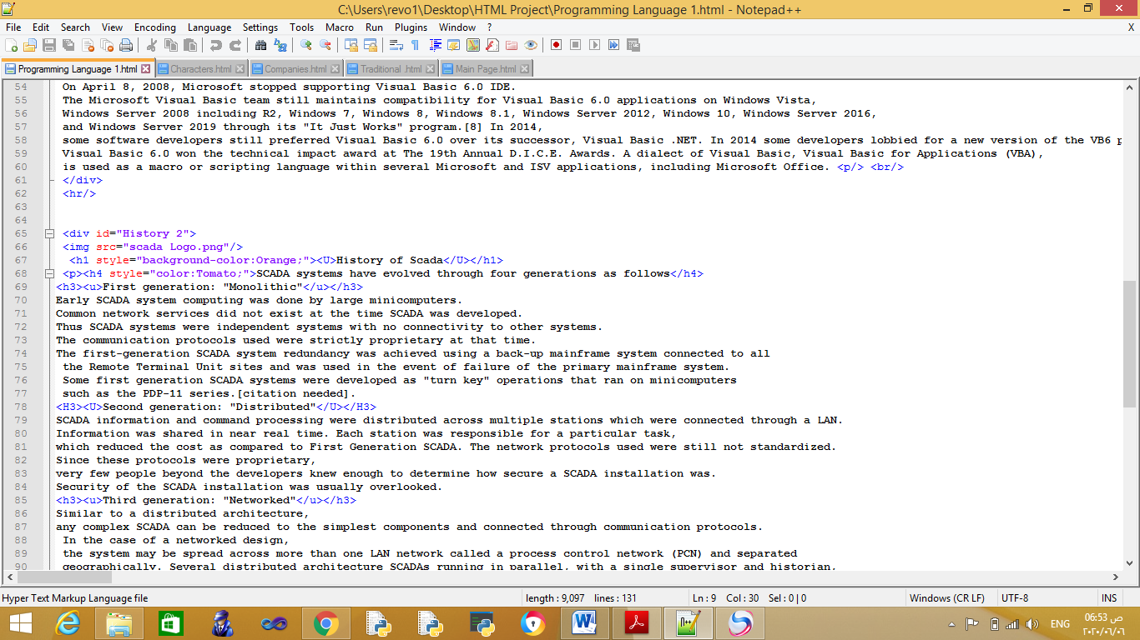

1. Characters Page

There must be more personalities in the field of software, whether with science and innovation, or with the financial capabilities that helped in the production of software.

On this page, we display some of the personalities associated with this field effectively.

Source of Data

<https://www.thecrazyprogrammer.com/2014/02/the-top-10-greatest-programmers-in-the-world-of-all-time.html.html>

<http://www.arkhitech.com/blog/12-greatest-programmers-of-all-time/>

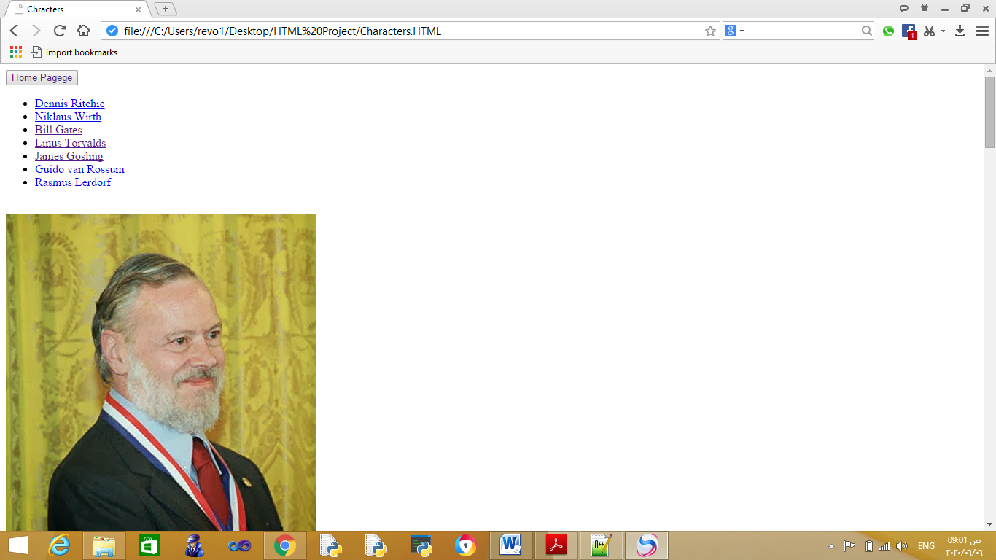

Page Screenshots

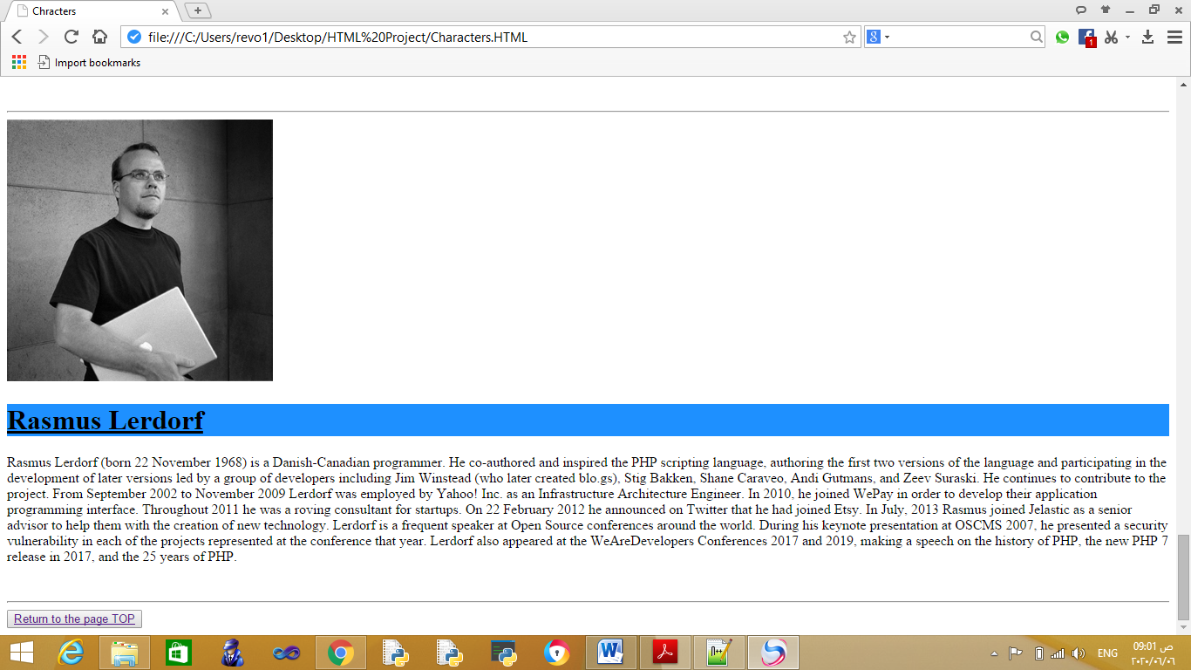

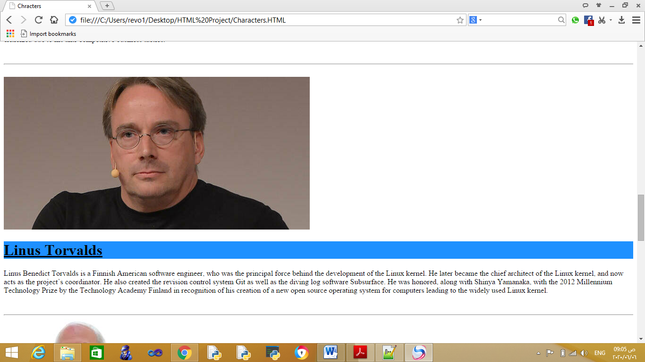

Codes Screenshots

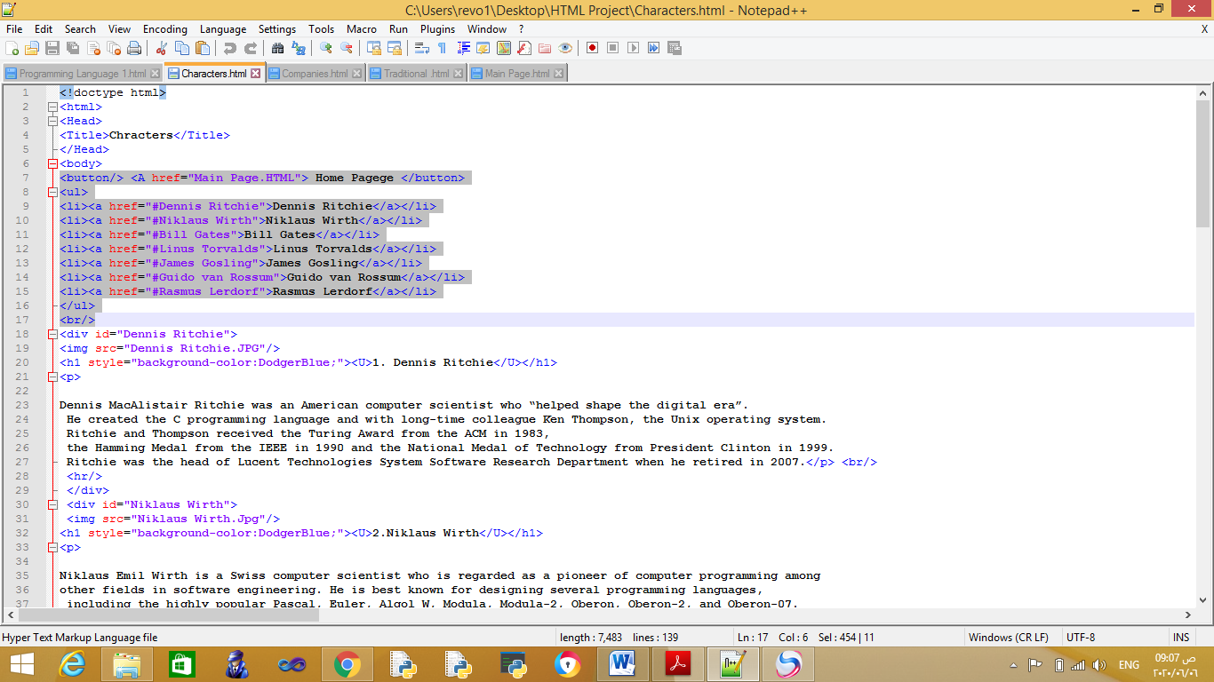

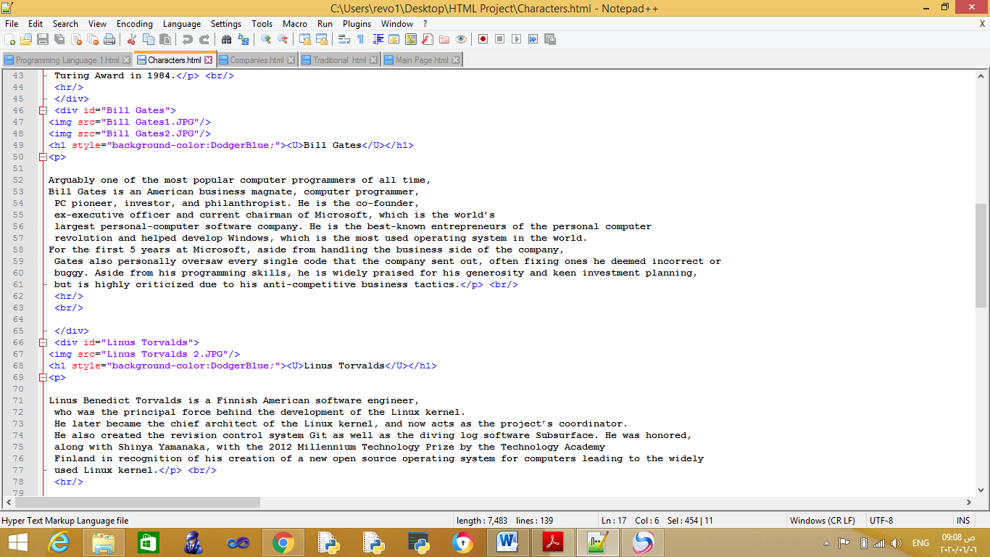

1. Companies that related by Production of Programming Language

This page displays examples of some companies that are in turn specialized in producing, supporting and developing programming languages

Also, a table was presented showing the name of the company and its headquarters, as well as its sales volume

And the necessary links have been placed on the page in order for the user to easily navigate the page

Also, pictures were created showing the logo of each company in a consistent manner.

Source of Data

<https://www.argaam.com/ar/article/articledetail/id/472958>

Vmware

<https://en.wikipedia.org/wiki/VMware>

SAP

<https://en.wikipedia.org/wiki/SAP_SE>

Oracle

<https://en.wikipedia.org/wiki/Oracle_Corporation>

Microoft

<https://en.wikipedia.org/wiki/History_of_Microsoft>

Apple

<https://en.wikipedia.org/wiki/History_of_Apple_Inc.>

Page Screenshots

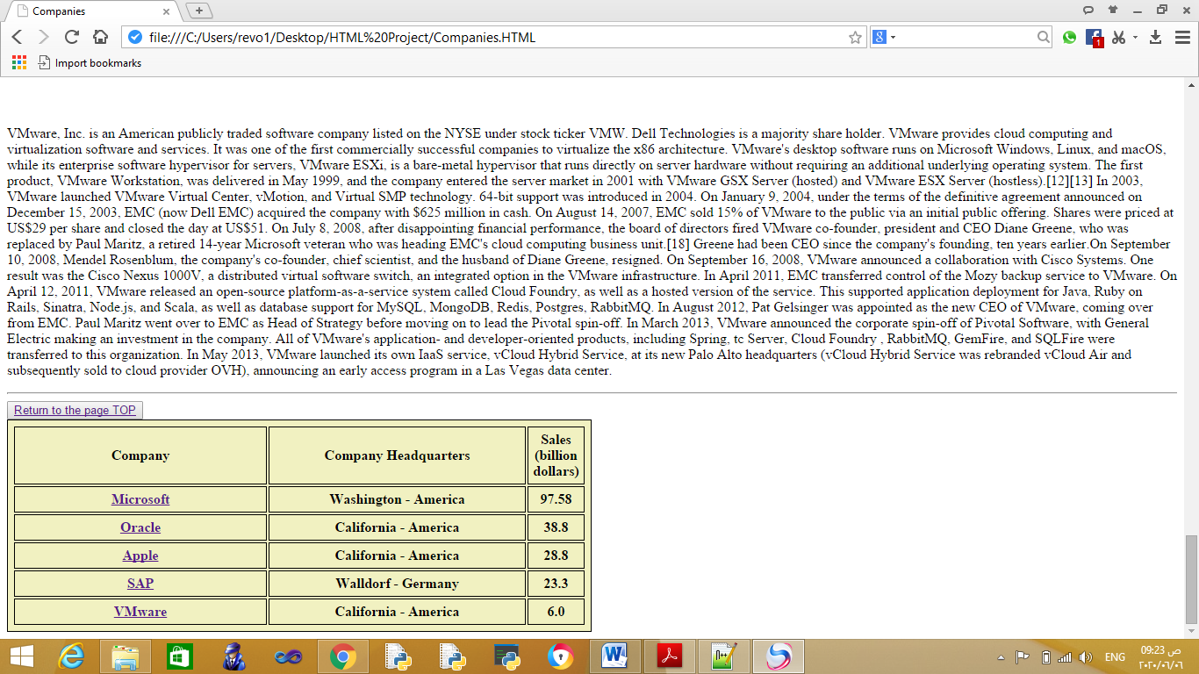

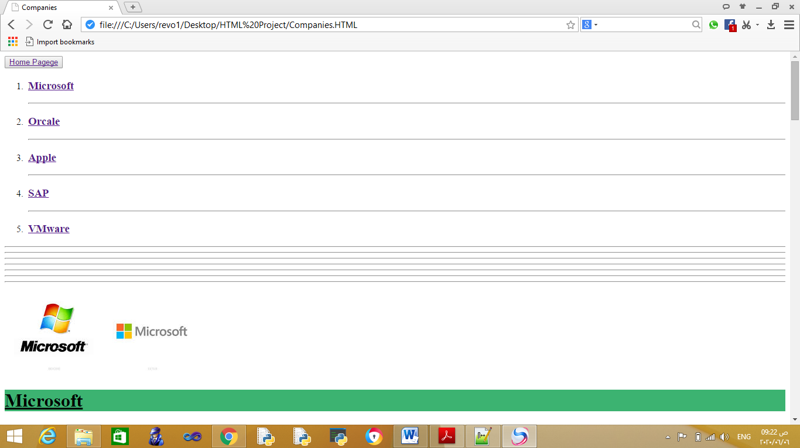

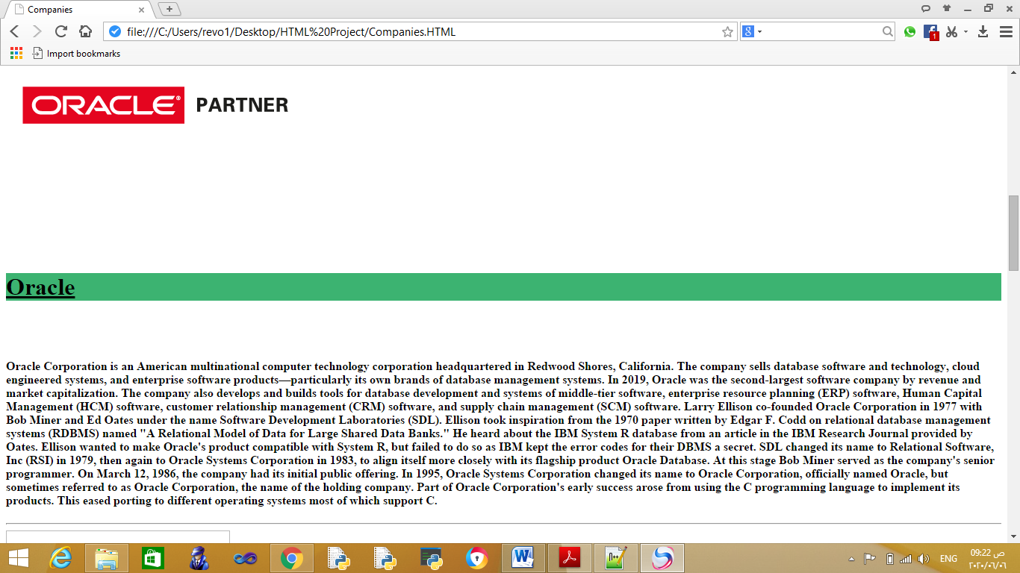

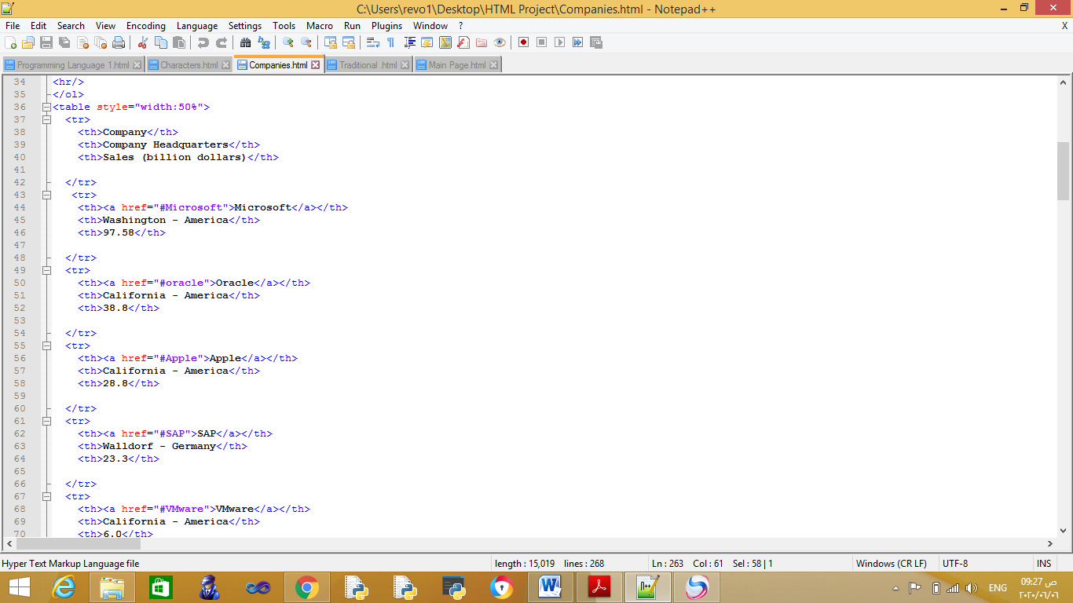Codes Screenshots

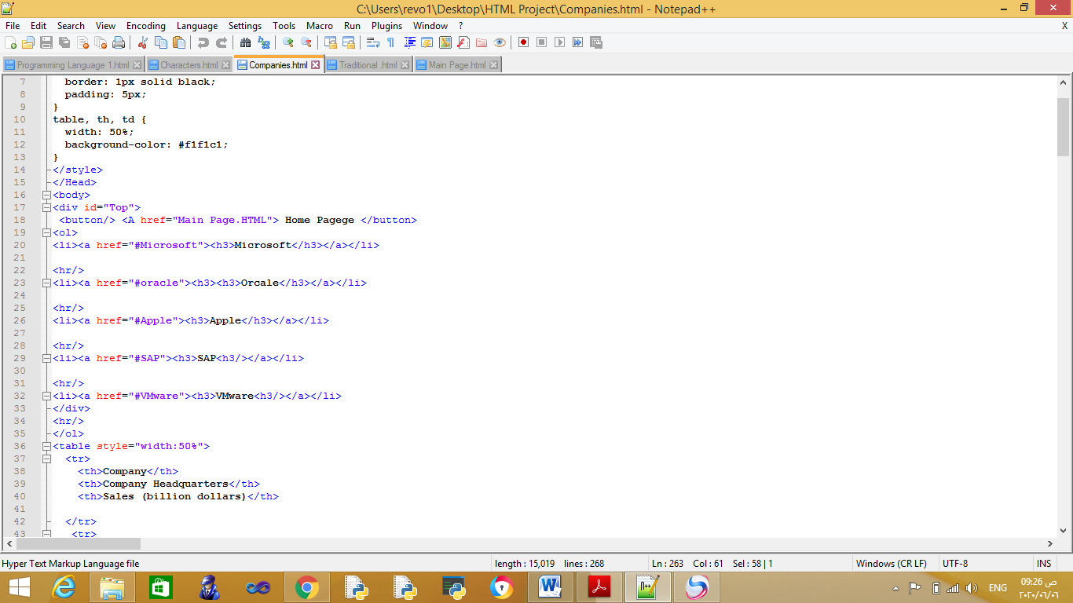

1. Types of programming language

On this page, we display general tire types, programming languages, and highlight various examples for each.

Source of Data

Traditional Programming Language

<https://www.pcmag.com/encyclopedia/term/standards-programming-languages>

High Programming Language

<https://en.wikipedia.org/wiki/High-level_programming_language>

Event Driven Programming Language

<https://en.wikipedia.org/wiki/Event-driven_programming>

Low level Programming Language

<https://en.wikipedia.org/wiki/Low-level_programming_language>

Very High Programming Language

<https://en.wikipedia.org/wiki/Very_high-level_programming_language>

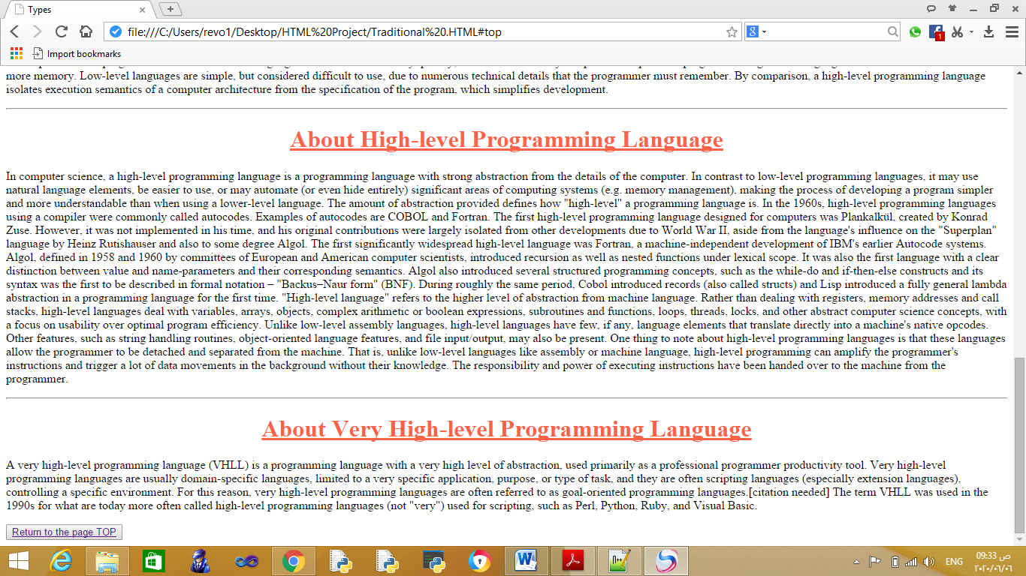Page Screenshots

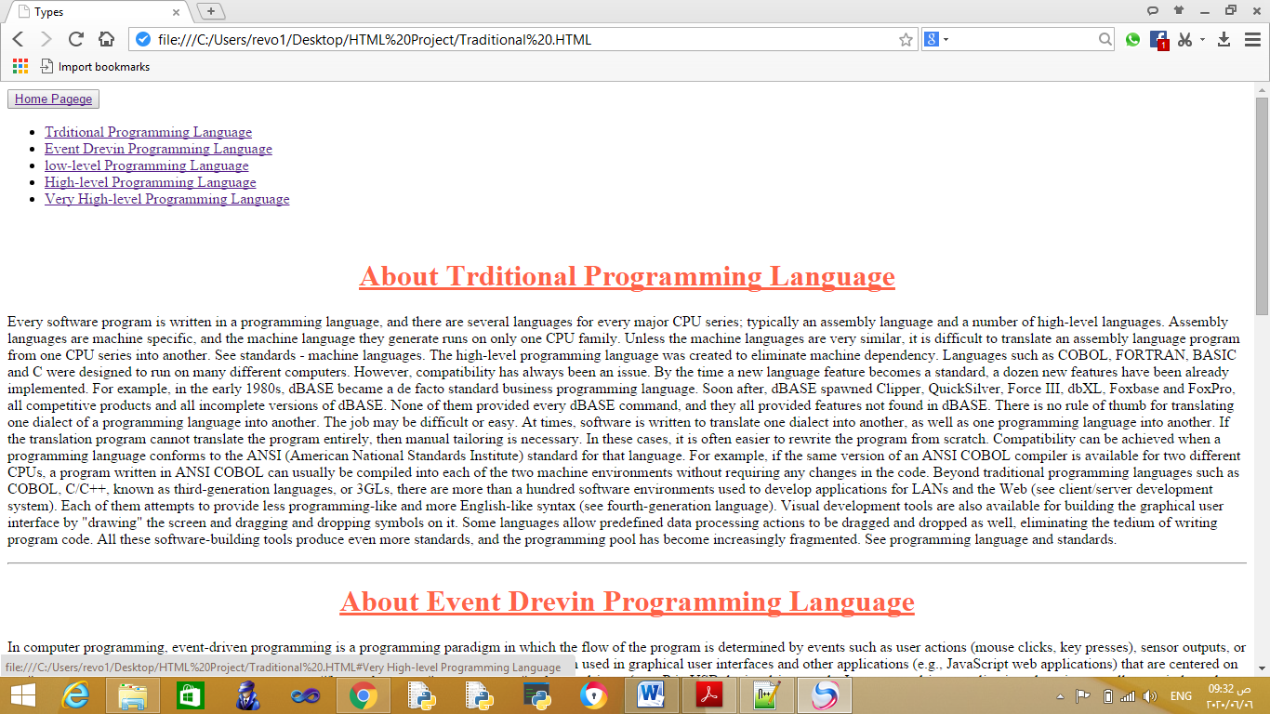

Codes Screenshots

